(Approx. 504 words)

Recover Your Wi-Fi Password
By David Kretchmar, Computer Technician, Sun City Summerlin Computer Club
Gigabyte Gazette Newsletter
www.scscc.club
dkretch (at) gmail.com

Computer users often seek technical support when they are unable to access the Internet via their home wireless system.

First, the technician will usually walk the user through the reset procedure for the router or router/modem (turn them off and on). If that does not fix the problem and it is determined the router is putting out a good signal the subsequent conversation often goes something like this:

Technician: What is your password for your router?
User: I don’t have a password.
Technician: If your router is not secured (i.e. password protected) you should be able to connect to it.
User: I don’t have a password. I just click on the Google (or another browser) icon and get online.

At this point, the Technician explains to User that the Wi-Fi password is stored on User’s computer and that a few steps are required to access that password. The technician might guide the user through a process to recover the password using the following procedure.

If the computer connects to the Wi-Fi automatically
With the latest version of Windows 10, Microsoft has buried the Wi-Fi password on a computer more deeply than with prior versions of Windows. You can still find your Wi-Fi password using the following procedure:

Find your way to the “Wireless Properties”
Right-click on the Internet access icon on the right side of your Taskbar then click on “Open Network and Internet Settings.” Click on “Status” then click on “Network and Sharing Center.”

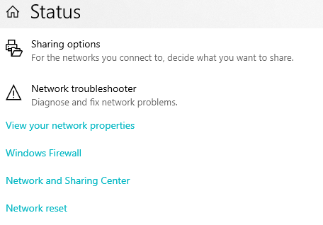
Under “Internet” click on your network name (in blue) then click on “Wireless Properties.”
Under “security” you can see the hidden password after you click on “show characters.”

If you only own a smartphone/tablet or have a PC which has not stored the Wi-Fi password
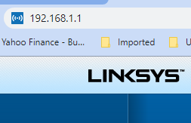
Log in to your router as an administrator. You can access your router by entering its IP address into your browser, such as Google Chrome or Microsoft Edge. You can research the default IP address of your router by Googling “IP address [brand name of your router]. Every router I’ve dealt with had an address of “192.168.X.Y.” The most common value for both X and Y is the number 1. If that does not work, try substituting the numbers 0 or 2 for X.

After you’ve logged in, you should be able to find the Wi-Fi settings on the Administrative pages of your router. There you can look up your Wi-Fi password.

If you are like many people
The Wi-Fi password is written on a sticker on the back of your router. This is how I usually set up home routers and it might be a good thing to do after you have recovered your Wi-Fi password.

This is a simple but effective strategy since it is so easy to find.

A burglar would have to break into your home to steal your password, and they probably would focus on more tangible items.

